EVENTME

*Implementation Document*

Alice Han hanalice@usc.edu

Oscar Hong othong@usc.edu

Yoonsoo Nam yoonsoon@usc.edu

CSCI 310 Team 30

*November 7, 2022*

# Contents

**Contents** **1**

**Preface** **2**

**Introduction** **3**

1.1 Motivation and Value 3

1.2 Product Scope 3

1.3 Main Functions 3

1.4 Business Context 4

**Architectural Design Changes** **5**

**Detailed Design Changes** **6**

**Requirements Changes** **8**

# Preface

As the global pandemic winds down and the weather is getting better, people have a need to attend different in-person events. But students and other individuals who may be financially insecure or money-conscious don’t particularly want to spend money on every single event being offered. Hence, EventMe is an application that will help users find free and/or cheap local events and register for them.

# 

# Introduction

### 1.1 Motivation and Value

With people going back to in-person normalcy, there is an increase of demand for in-person events. However, the limiting factors for attending events are proximity, money, and time. EventMe is a solution to this that helps users find curated events fitting their needs.

### 1.2 Product Scope

EventMe is a convenient application that will help users find free and/or cheap local events and register for them.

### 1.3 Main Functions

1. Explore the nearby events
   1. Search based on event type (e.g. music, arts, outdoor, etc) through buttons or tabs
   2. Search bar search for name of the event, location, or sponsoring organization
   3. Indicate range of dates to find only those events that fit the timeframe
   4. All of these events can be sorted from in the “Event Box” for
      1. Lowest to highest cost (default)
      2. Proximity
      3. Earliest to latest date
      4. Alphabetical
2. Map
   1. All events shown as markers
   2. When an event is clicked on, it will show in the “Event Box”
   3. Swiping up from the “Event Box” will take user back to map
3. Register
   1. On Events Registration page, users can see all information regarding the events
   2. When clicking on the Register button,
      1. If user not logged in, redirect to Login/Register
      2. If logged in and has not registered, successfully register ONLY if there is no conflicting events
         1. If conflict, warn user
         2. If they want to proceed, they can
      3. If logged in and has registered, ask to unregister
         1. If yes, event removed from the user’s registration
   3. All events will be shown in the Profile Tab

### 1.4 Business Context

The application is similar to Eventbrite. Eventbrite lets you browse, create, and promote local events. Also, a feature in Facebook, events, is a similar context where you can create local events. The difference is that we do not sell tickets but rather allow users to register. Also, we are different from Facebook's function because we do not require a social media connection or login to register for an event.

# Architectural Design Changes

During our implementation, we made no significant changes to our holistic architectural design.

The major components all stayed the same: the Presentation Layer (the UI of the application), Business Logic Layer (user request), Data Access Layer (requests to the Data Storing layer), and Data Storing Layer (where the data is stored). The diagram is attached below again for reference.

# 

# Detailed Design Changes

Initial Wireframe

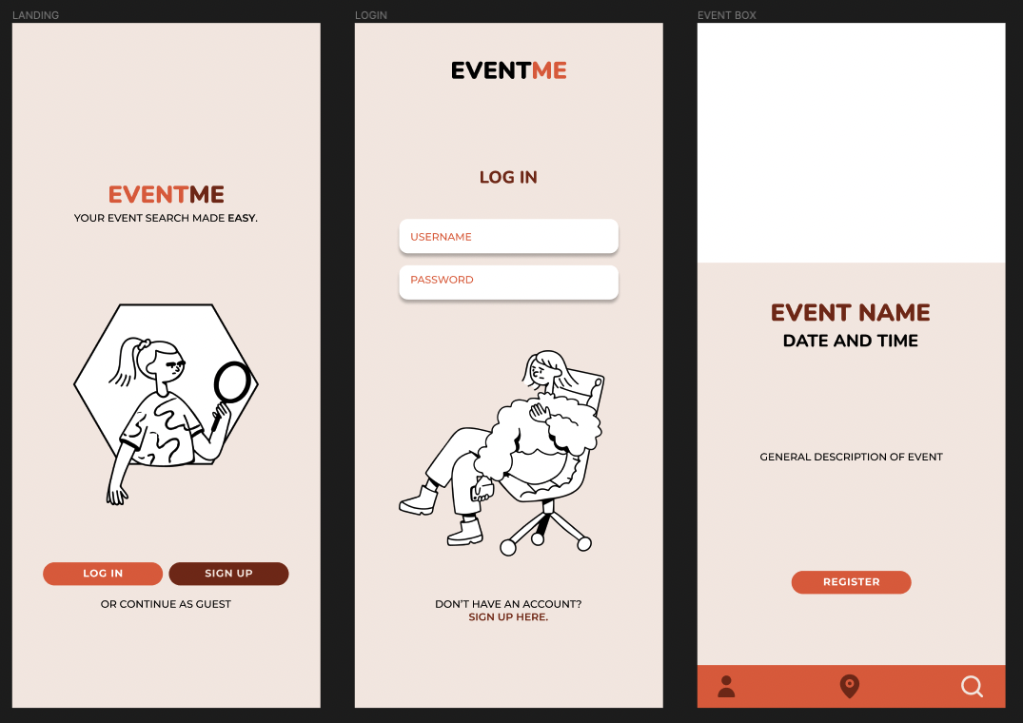

Implemented Design

# 

The reason we changed the design was that the minimal look seemed cleaner and more user-friendly. The initial wireframe looked nice but from the user’s perspective, it could get confusing. That is why we stripped away all unnecessary components so that we give users straightforward direction on what they can do on the page.

# 

# Requirements Changes

1. Decided to not implement swiping motion from the event box in the map.
   1. Reasons:
      1. Swiping motion is not intuitive
      2. Swiping motion can look like a glitch
      3. There is a clear direction in the bottom navigation bar to navigate to the explore page